CIElab Based Color Feature Extraction for Maturity Level Grading of Mango (Mangifera Indica L.)

S. Naik¹, Dr. B. C. Patel²

ABSTRACT

Mango is considered as king of the fruit. Currently human experts do Mango grading process manually. Here method for automated grading of Mango fruit based on image processing is proposed which uses color feature extraction. Proposed method contains three phases. In first phase pre-processing on captured image is performed. Region property extraction and color feature extraction is performed in second phase. Finally histogram analysis is performed and Mango is graded in three classes namely Unripe, Partially Ripe and Ripe. Color feature extraction is performed in L*a*b* color model using dominant color method. Proposed method is not limited to laboratories and can be used in the real world as it gives very high accuracy and grade Mango in real time.

Keywords: Color feature extraction, Image Processing, dominant color method.
- INTRODUCTION

Mango (MangiferaIndica L.) belonging to family of Anacardiaceae is one of the major grown fruit crops of South Gujarat. Mango varieties cultivated in Gujarat state include Totapuri, Dashehari, Langra, Kesar, Rajapuri etc. The external appearance is one of the most important factors in pricing the Mangoes. The criteria for evaluating a Mango’s external appearance include color on the surface, a visually mouth-watering appearance, and a good shape/size.
Grading based on color parameter is widely used and carried out manually. This manual grading is purely depending on experience of people involved in the grading process and also varies from person to person. So, there may not be consistency between groups of graded Mango.
For a human it is very difficult to focus on outer parameters like color, size, shape, disease etc. at the same time. So ultimately process of grading will get slower and among group of graded Mango, we may find variation.
On the other hand, the image processing method has gain popularity in automation of manual task. The human factor is eliminated and hence quality can be achieved at all levels.Color is very important parameter for Mango grading and most of the time Mango grading process considers color parameter only. Different image processing algorithms have been developed by researchers to improve accuracy of color based sorting systems.
The shape and color features are calculated from area and perimeter of fruit and nearest mean classifier is carried out for classification of 12 classes of fruitsin [2] but less samples of fruits reduce the accuracy of grading.An automated Mango grading system based on size (area) color and skin feature (mean value of R, G, and B) was developed in [12].
Fuzzy rules were considered to compute grade of Mango. Based on maturity level, automatic system of Mango grading was made in [9]. Color parameters of Mango were estimated using Gaussian Mixture Model. Accuracy achieved is below 90%.
Ripeness of Mango is defined in terms of maturity index (Im), a ratio of total soluble solids (TSS) under examinations and minimum level of TSS of matured Mango in terms of percentage. Hunter Lab colorimeter was used to measure immature to mature range of Mango by finding values of L, a, b. Handheld refracto-meter was used to judge TSS of whole Mango juice. Different models like multiple partial least square (PLS), linear regressions (MLR) and principal component regression (PCR) was used.Varieties of model and more samples make stronger prediction of maturity [4].
Wavelets are used for coarse and fine grading of Mangoes using shape descriptor and size (radius signature). In this research, Defectidentification can make real time application [6].Fuzzy logic and size based grading system, using minimum entropy formulas, was developed in [13]. Accuracy was low compared to other grading system. Gaussian Mixture Model (GMM) and fuzzy logic was combined for size based grading of Mango[10].
Current grading systems[11] are lacking in accuracy for sorting fruits. Current grading systems are considering few parameters like color and size only. Even accuracy is not achieved more than 95%.Table I summaries Mango Grading systems.
Our main objective is improve the accuracy, reduce computation time and to consider more parameters for grading like color, size, shape and disease.
In this paper, algorithm for Mango grading using color feature extraction is presented and comparison is done on how color feature extraction method works on RGB, HIS and L*a*b* color model.
The paper is organized as follow. Section II contains material and methods, which include algorithm for color feature extraction, forMango grading. Discussions of results are shown in next section. We summarize our review and conclude this paper in Section IV respectively.
- MATERIAL AND METHOD
Mango grading system framework of our study is shown in Fig.1.First the image of Mango is taken. In pre-processing phase filtration is applied to get a new brightness value in the output image, which will help in image segmentation.
In the same phase image sharpening is done for proper boundary extraction and boundary smoothing is performed. Region properties like major axis and minor axis are extracted in the region property extraction phase for selecting region of interest (ROI). In color feature extraction phase, ROI is converted into L*a*b* color model and values of all three channels are extracted.
Finally histogram analysis of three channels is performed and Mango is classified in different grades according to dominant color method. The same process in the form of algorithm is presented in table 2.

Table 1 Mango grading system with its features
Fruit | Feature | Accuracy | References
Mango | Color | - | Nandi et al., 2012-2014
 | Color | 95.67% | Bejo K. et al., 2011
 | Color | >90% | Chopra S. et.al.,2007
 | Color | - | Ahmad et al., 2005
 | Size and color | >80% | Tajulet al, 2012
 | Color and Fractal Dimension | 85.19% | Hong et al., 2012

Figure 1 Framework for Mango grading system

Table 2 Proposed algorithm
Algorithm for Mango grading
1 | Image acquisition and preprocessing
2 | Image segmentation
3 | Extract boundary from Mango region and fill the patches
4 | Find region properties and plot rectangle in Mango region(ROI)
5 | Convert ROI into L*a*b* color model
6 | Extract color feature from ROI
7 | Plot histogram and analyze the color range of Mango using dominant color method.
8 | Classify Mango in ripe, partially ripe and unripe.
- SAMPLE COLLECTION
For experiment purpose, Mango images are captured in studio setup. Camera used is Nikon DSLR – D90 containing 18.105mm lens. Studio light distance from Mango is maintained as 53cm. Height from Mango is maintained 78cm(Images are captured from top view). Camera used focus mode AF-A andnormal flash. Database of 100Mango images has been created which contains 36 unripe, 27 partially ripe and 37 ripe Mango images. Sample images are shown in below fig.2.

Figure 2 Mango samples of ripe and unripe Mangoes
- IMAGE PREPROCESSING AND SEGMENTATION
The captured image is in RGB color space. It is converted to gray scale for segmentation. Image is resized to reduce computational complexity. Median filter is used to remove noise and image sharpening is done for better boundary extraction. The image is then segmented to separate Mango image from background as shown in fig.3. A background consists of white paper, which is in contrast with Mango. So suitable threshold value is used to perform segmentation. OTSHU algorithm is used to find threshold value as it reduce complex mathematic operation and provide better result [5].
This segmentation process is resulted in binary image, on which boundary extraction and boundary smoothing operations are performed. This binary image is then analyzed to extract region properties and color feature from original image.

Figure 3 Segmented image from original Mango image

- REGION PROPERTIES
Mango starts getting ripe from apex region and value of color getting change from apex to stalk region [10]. Apex region and stalk region are shown in fig.4a. If we consider middle region only as shown in fig.4b (Blue strip) instead of considering full Mango image for color feature extraction, it will reduce considerable computational time as less number of pixels needs to be considered for middle region (Blue strip) then full Mango image. So from segmented image, region properties like area, centroid, orientation, major axis length, and minor axis length are derived.
By considering middle region only, we have reduced 30%(1.3122 seconds to 0.9886 seconds) computational time in our experiment. Here 15% of the area (Blue strip) on both the side of major axis has been considered for color feature extraction.
We can choose more than 15% area if we could not get proper classification. In our experiment same classification is achieved for 15% area as well as for full Mango.
- COLOR FEATURE EXTRACTION
Color is an important feature in determining maturity and disease of Mango.Captured images were in RGB color model but RGB is a poor choice for color analysis due to high complexity in analysis [1]. We have used L*a*b* color channel for color classification because the human sight is more interested in major color of the image. Therefore, Mango images were converted from RGB space to L*a*b* color space. Only middle region of original image is converted into L*a*b* color space so the computational time can be decreased.

(a) | (b)

Figure 4a) Apex and stalk region b) Region property with rectangle
On this converted part dominant color method[15] is used to do color feature extraction. Below we have explained the dominant color method.

Table 3 Dominant Color method
Algorithm for dominant color method
1 | Image is represented in three channel L*, a* and b*.
2 | Calculate histogram of an image on a* channel and b* channel only.
3 | To find color range from histogram, Sets a window of width L, and then from the most left of the histogram the gray value of the window is calculated.
4 | Window is moved one pixel towards right and again the gray value is calculated. This procedure continues until window is moved towards the most right.
5 | Find the window having the largest frequency (dominant window). And then use the average color value of the dominant window.
In step 3 of dominant color method as describe above, window of width L is taken. We have done the experiments with window width L=3,6,9,12 and 15. Time taken by window width 3 is 0.022 seconds, 6 is 0.012 seconds, 9 is 0.0087 seconds and 15 is 0.0078. As shown in fig.5, in window width 3 and 9, there is no overlapping of values for channel a* and b*. From window width 12 onwards we have got overlapped values of channel a* and b* which give misclassification. The time is also not getting reduced much after window width 12. So we have chosen window width 9, which gives better and faster results.
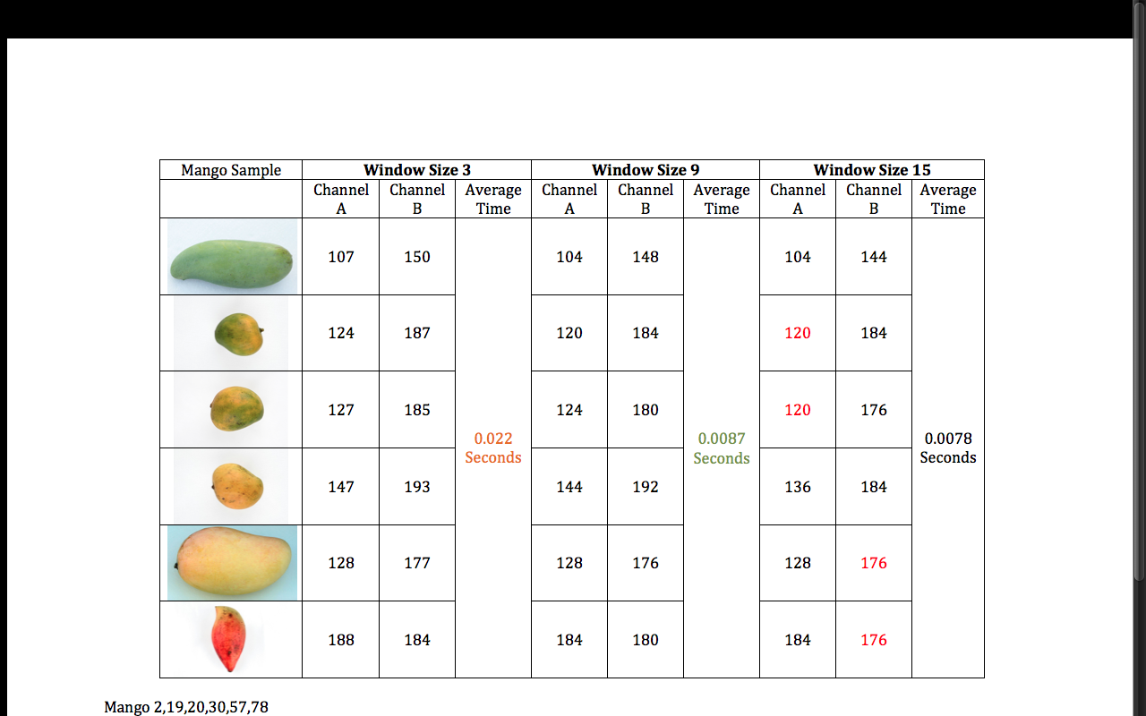

Figure 5 Results of dominant color method with window size 3,9,15
- HISTOGRAM ANALYSIS AND GRADING CLASS
As shown in fig.5 color feature is extracted using dominant color method in L*a*b* color model. From histogram analysis of a* and b* channel of all 100Mango images, we have derived color range for unripe, partially ripe and ripe Mango. Fig.6 shows channel A histogram of L*a*b* color space for unripe, partially ripe and ripe Mango images and table 4 summarize the range.
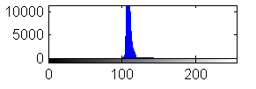
(a)
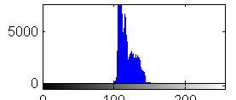
(b)
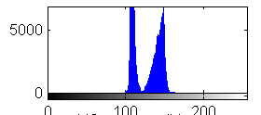
( c)

Figure 6 Chanel A histogram of L*a*b* color space for a) Unripe Mango b) Partially Ripe Mango c) Ripe Mango
- RESULTS AND DISCUSSION
An experiment was conducted with MATLAB r2013a with MacBook Pro having MAC OS X (version 10.9.2), 2.5 GHz Intel Core i5 processor, 4GB 1333 MHz DDR3 memory and 1GB Intel graphics card. Three color model RGB, L*a*b* and HSI were used for comparison to find maturity of Mango.
Fig.7 shows the value distribution of each channel for Mango images. From fig.7a, it can be observed that correlation of maturity is high and it increase from B, G and R channel.Similarly, HSI channel has high correlation between ripe and partially ripe Mango as shown in fig.7b Prediction using maturity of Mango using L*, a* and b* channel is very good as compared to RGB and HSI model. So we can say that RGB and HSI are poor for classification of Mango based on maturity compared to L*a*b* model.
Table 4 Color range for ripe, partially ripe and unripe Mango

 | Channel A | Channel B
Unripe | 80-115 | 140-180
Partially ripe | 116 -135 | 170-190
Ripe | 136-150 | 180-210

We have done experiment twice. In first experiment, color feature is extracted from full Mango image and grading is done. In second experiment only middle region is used and grading is done. In both cases we have achieved 96% accuracy for our database.
As Mango grading should be real time, our main aim is to reduce computation and response time. Execution time for one Mango image with consideration of full region is 1.3122 seconds while for middle region only is 0.9886 seconds.
Table 5 summarizes our experiment results.
Figure 7 a) Variation of R, G and B of Mango with maturity levels,
b) Variation of H,S and I of Mango with maturity levels,
c) Variation of L,a and b of Mango with maturity levels.

Table 5 Experiment results for Mango grading
 | Unripe | Partially Ripe | Ripe
Images in Database | 36 | 27 | 37
Successfully Classified | 34 | 25 | 37
Misclassified | 2 | 2 | 0

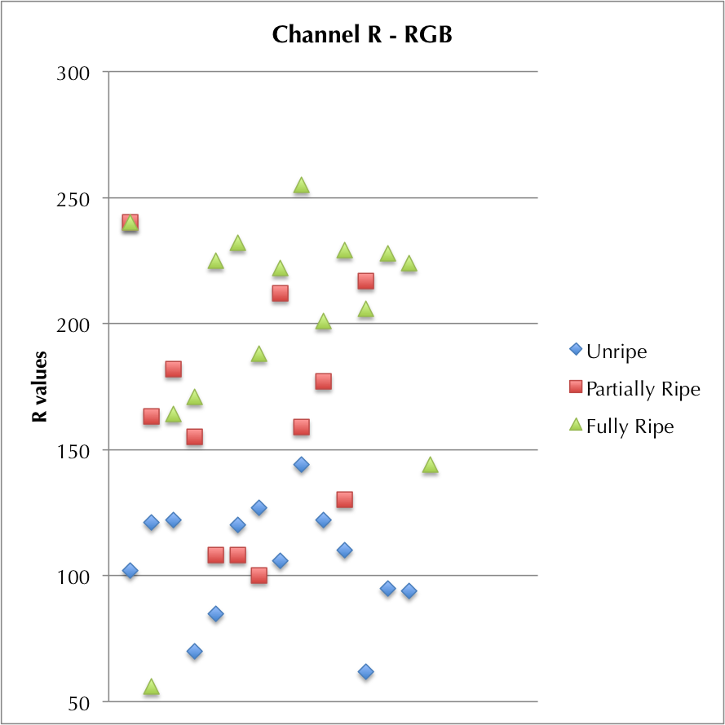 | 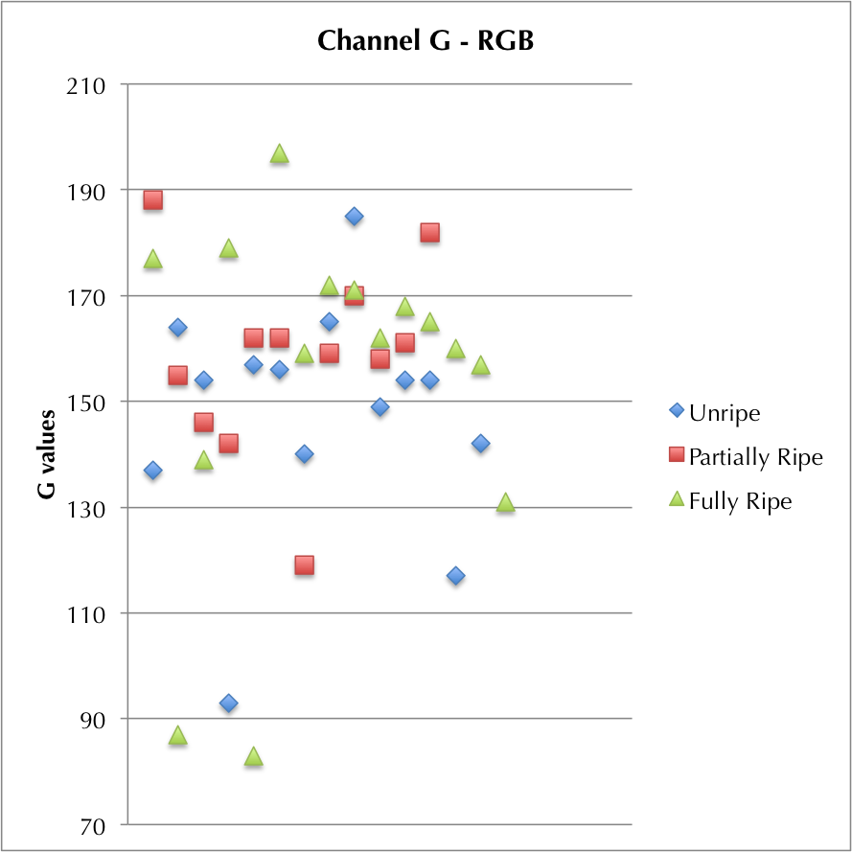 | 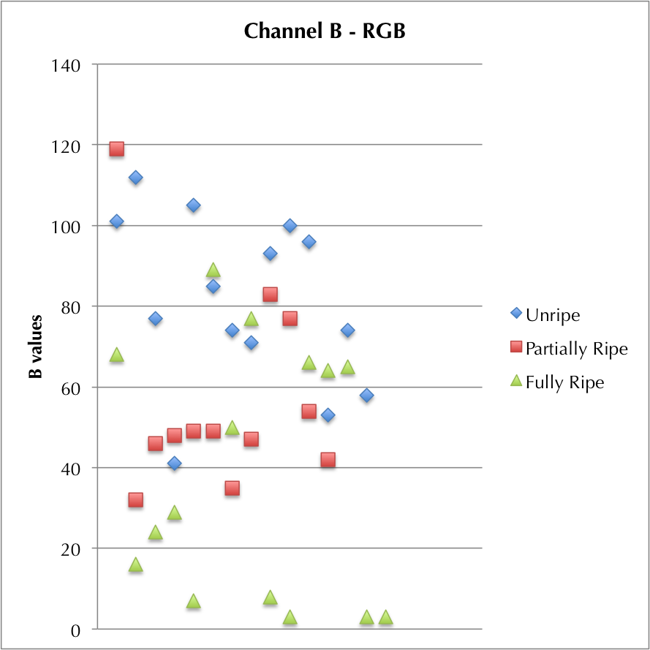
(a)
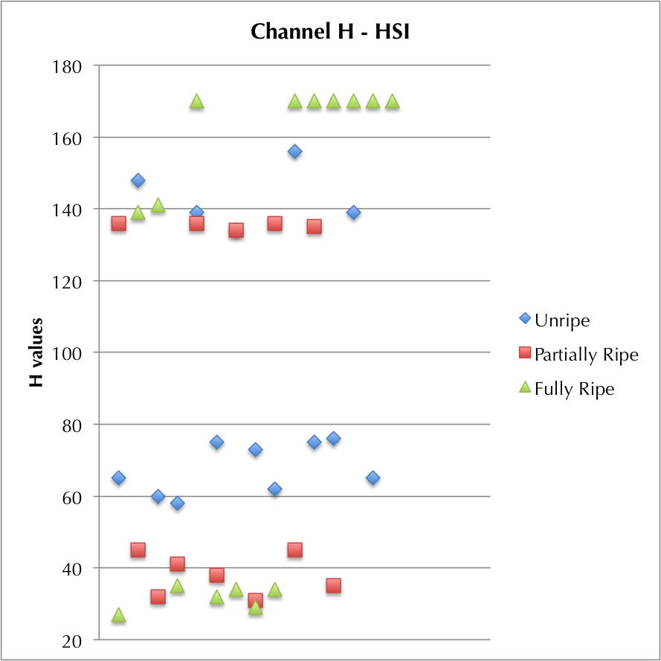 | 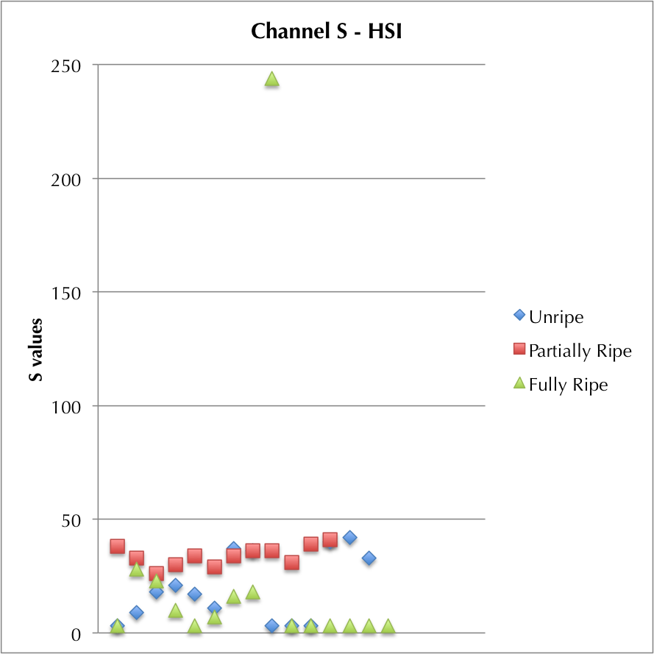 | 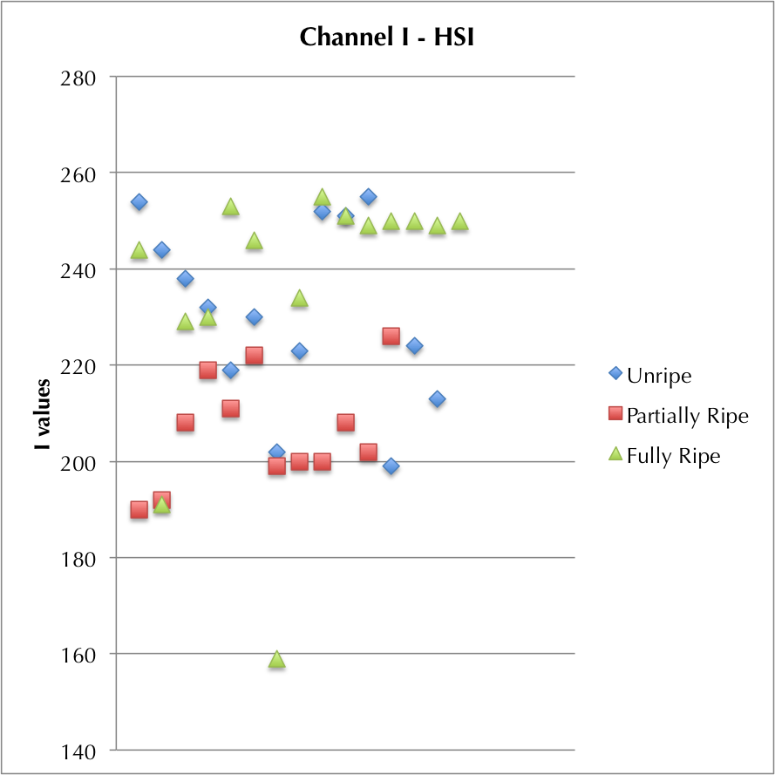
(b)
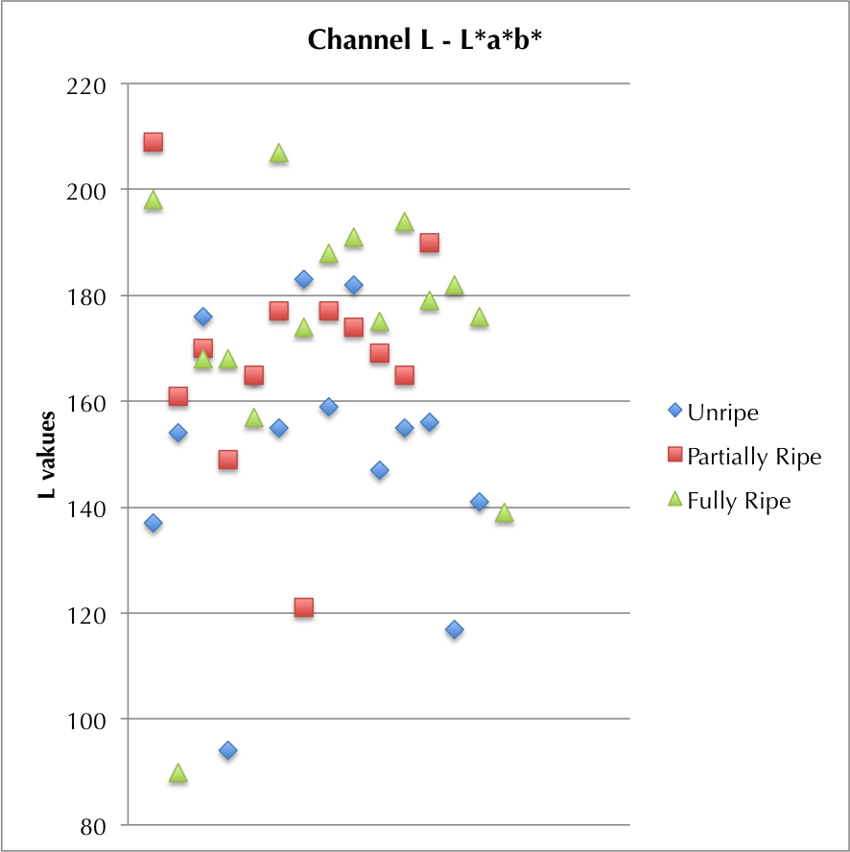 | 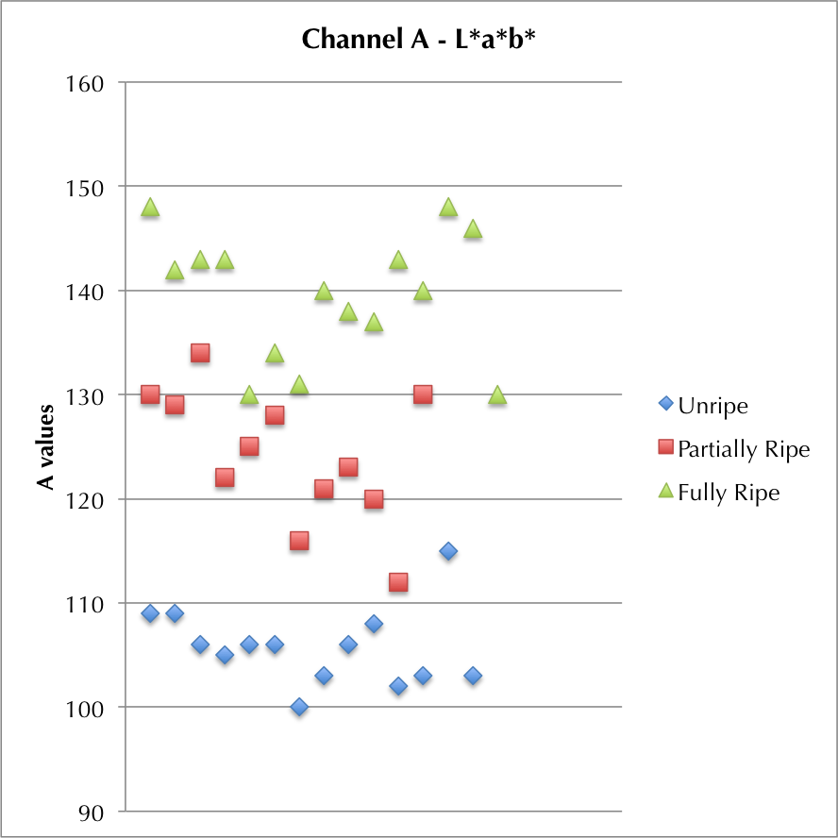 | 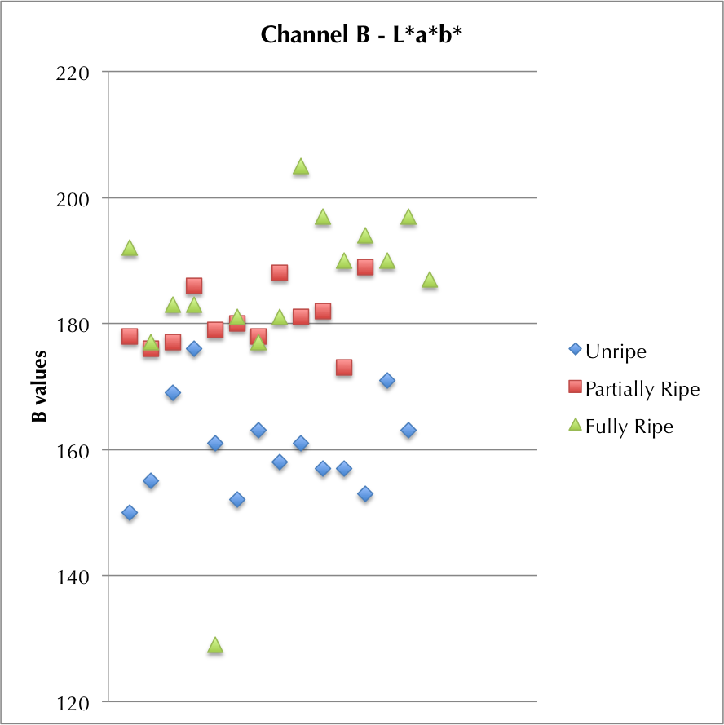
(c)

- CONCLUSION
From our experiments and proposed model, we have concluded that the L*a*b* color model is the best choice for color feature extraction for Mango grading. Our experiments for dominant color method also conclude that window width 9 is the best choice for color feature extraction. Our proposed algorithm gives 96% accuracy. Experiments also proves that, considering only middle part of Mango image instead of considering full Mango image gives 96% accuracy and reduced execution time by 30% one Mango image. In future, region properties of our proposed method can be used to grade Mango using size feature without adding extra execution time as we can get equation, which do map major and minor axis length with real length of Mango.
- REFERENCES
- Cheng andHeng-Da, “Color image segmentation: advances and prospects,”Pattern recognition, 34.12: 2259-2281,2001.
- Harjokoet al.,“A Fruit Classification Method Based on Shapes and Color Features,”Proceedings of Asian Physics Symposium, Vol. 8. No. 1, 2012.
- Hong Z. and Lu H.,“A least-squares support vector machine (LS-SVM) based on fractal analysis and CIELab parameters for the detection of browning degree on Mango (Mangiferaindica L.)," Computers and Electronics in Agriculture, vol. 83, pp. 47-51, January, 2012.
- Jhaet al., “Modeling of color values for nondestructive evaluation of maturity of Mango,” Journal of Food Engineering, Vol78. No.1 .pp no.22-26, 2007.
- Jun Z. andJinglu H.,“Image Segmentation Based on 2D Otsu Method with Histogram Analysis,”Computer Science and Software Engineering, International Conference on (Volume:6 ), Page(s):105 – 108,Print ISBN:978-0-7695-3336-0, 2008.
- KhojeS. and Bodhe S.,“Determination of applicability of mother wavelet for coarse and fine grading of Mangoes”. Advances in Technology and Engineering (ICATE), International Conference on. IEEE, 2013.
- KhairunnizaB. et al., “ChokananMango Sweetness Determination Using HSB Color Space," Computational Intelligence, Modelling and Simulation (CIMSiM), Third International Conference on. IEEE, 2011.
- Ministry of Commerce & Industry, G. o. (n.d.). APEDA, from Agricultural & Processed Food Products Exports Development Authority.Retrieved March 2, 2014,[Availableon] http://www.apeda.gov.in/apedawebsite/SubHead_Products/Mango.htm
- Nandi et al.,"An automated machine vision based system for fruit sorting and grading," Sensing Technology (ICST), Sixth International Conference on. IEEE, 2012.
- Nandiet al.,“Machine Vision Based Techniques for Automatic Mango Fruit Sorting and Grading Based on Maturity Level and Size,”Sensing Technology: Current Status and Future Trends II. Springer International Publishing, 27-46, 2014.
- Naik S. and Patel B.,“Usage of Image Processing and Machine Learning techniques in agriculture-Fruit sorting," CSI communications, Volume No. 37, Issue No. 7, pp. 24-26, October, 2013.
- TajulRosli Bin Razaket al., “Mango Grading By Using Fuzzy Image Analysis,”In proceedings of International Conference on Agricultural, Environment and Biological Sciences, Phuket, 2012.
- Teohet al., “Automated Mango Fruit Grading System Using Fuzzy Logic,” Journal of Agricultural Science (1916-9752), 2014.
- The Economic Survey, Agricultural and Processed Food Products Export Development Authority (APEDA), The Union Budget 2013-14, Press Releases, Media Reports website [Available on] http://www.ibef.org/industry/agriculture-india.aspx
- Xu Liming and Zhao Yanchao,“Automated strawberry grading system based on image processing, ”Computers and Electronics in Agriculture, vol. 71, no. Supplement 1, pp. S32-S39, April 2010.

AUTHORS’ PROFILE:

S. Naik
Assisstant Professor
S. R. Institute of Management & Computer Application
Maliba Campus, Bardoli - Mahuva Road
Surat, India
e-mail: sapan.naik@utu.ac.in
Dr. B. C. Patel
Director,
S. R. Institute of Management & Computer Application
Maliba Campus, Bardoli - Mahuva Road
Surat, India
e-mail: bankim_patel@srimca.edu.in

